Part 1 – sample selection and pooling

1. Select samples with at least 50ng uL-1, and select arnd 5-10 samples per country and timepoint (each sample must be at least 100ng uL-1)
2. Dilute samples with nuclease free water, so that DNA concentrations are 50ng uL-1. Ensure at least 5uL is available
3. Mix 5uL of each sample together according to pool. Vortex. (total volume should be 50uL)

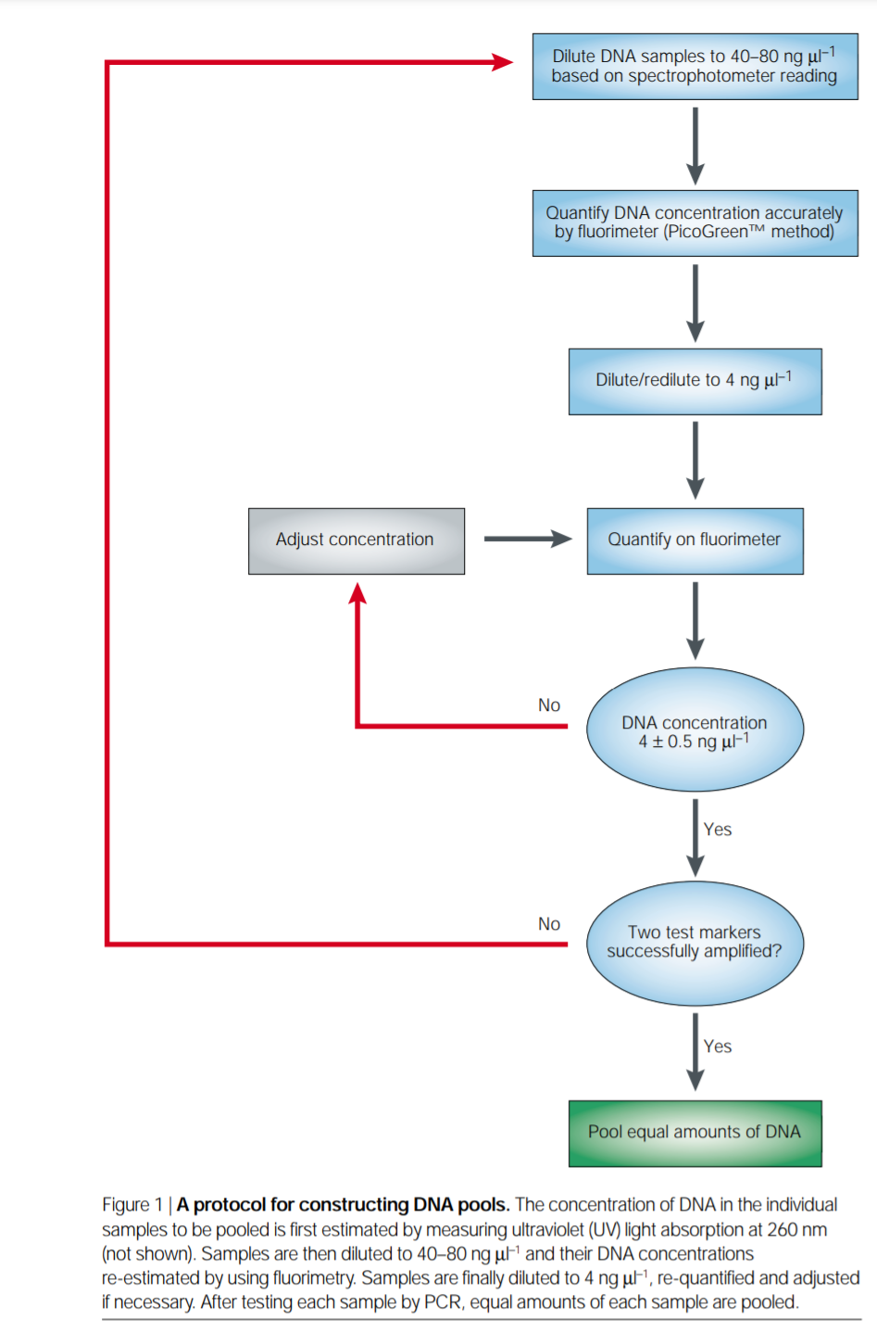

Part 2 – partial digestion

1. Mix 1 μg of mgDNA with 1–5 units of both BamHI and BglII (NEB) in a total volume of up to 90 μl. (Ideally 20uL) Regardless, ensure ratios are maintained as below (2 enzyme reaction)

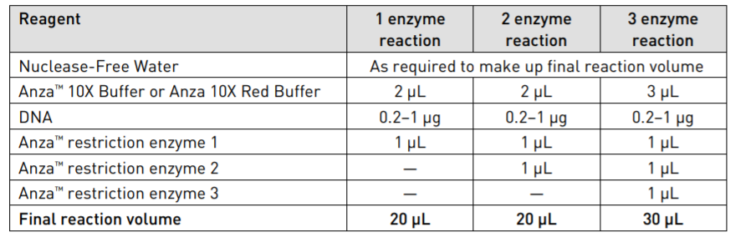

1. Digest in 37 °C in an Eppendorf incubator, withdraw 15 μl after 5, 10, and 15 min in an Eppendorf tube, containing 270 μl of absolute ethanol and 9 μl of 3M sodium acetate (pH=8) on ice.
2. Add 1–5 units of restriction enzyme BstYI (NEB) to the remaining digest. Maintain same amount as BamHI and BglII.
3. Continue incubation at 37 °C, while withdrawing 15 μl every 5 min and pooling with the tube in (5), on ice.
4. Vortex samples and incubate at −70 °C for 5–10 min.
5. Centrifugating for 10 min at full speed to pellet DNA
6. Wash once with 200 μl of 80% ethanol and recentrifuge.
7. Dissolve DNA pellet in 50 μl sterile water.

Part 3 – DNA size selection & purification, dephosphorylation, plasmid ligation

1. Select for and purify DNA fragments to >700bp inserts
2. Dephosphorylate ends of vectors in a 1 step dephosphorylation protocol. Mix reactants in the following ratios.

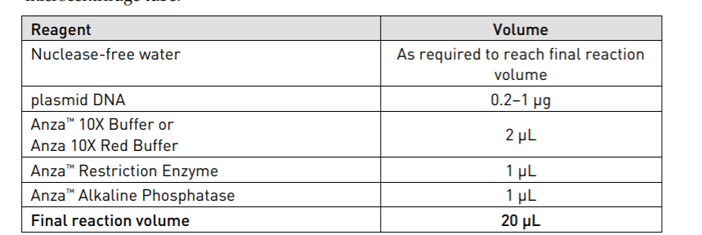

1. Pipette to mix, incubate at 37°C for 15 minutes
2. Inactivate enzymes via 80°C for 20 minutes
3. Add ligation master mix for ligation
4. Precipitate ligation mixture w/ 5uL 3M Sodium acetate (pH8) and 150uL of absolute ethanol
5. Incubate at 10min at -70°C, spin for 10 min
6. Wash DNA pellet twice with 80% ethanol, air dry and dissolve in 5uL sterile water.

Part 4 – Transformation into competent cells

1. Remove competent cells from the -80°C freezer and thaw completely on ice (10-15 minutes).
2. Aliquot 1-5 µl (1 pg-100 ng) of DNA to the chilled microcentrifuge tubes on ice. (Ideally, also have a pUC19 control to verify transformation efficiency)
3. When the cells are thawed, add 50 µl of cells to each DNA tube on ice and mix gently by tapping 4-5 times. (DO NOT pipette or shake vigorously). For the pUC19 (pUC118) control, add 1 µl of (10 pg/µl) DNA to the 50 µl of cells on ice. Mix well by tapping. Do not pipette up and down or vortex to mix, this can harm cells and decrease transformation efficiency.
4. Incubate the cells with DNA on ice for 30 minutes.
5. After the 30-minute ice incubation, heat shock the cells at 42°C for 45 seconds.
6. Transfer the tubes to ice for 2 minutes.
7. Add 950 µl of Recovery Medium or any other medium of choice to each tube.
8. Incubate tubes at 37°C for 1 hour at 210 rpm in a shaker incubator.

Part 4 – functional screening (antibiotics)

1. Take 100uL of the tubes and spread it each onto plates containing the following stressing conditions (should narrow down viable colonies so there are less to pick for AST later on)
   1. Antibiotics
   2. Heavy metals
   3. Bacteriocin
2. Incubate overnight at 37°C
3. Take the colonies that survived and grew on the plates in (29) and run AST for them.

Part 5 – functional screening (alcohol)

1. Take transformed cells from (27) and streak onto plates (incubate overnight) to form pre-stress colonies. (3 replicates per library)
2. Place transformed cells into 20mL LB broth containing 5% v/v ethanol and stress for 48 hours
3. Spread cells from (29) onto agar plates to count post-stress colonies (3 replicates per library)
4. Pick out 8 random clones from each library’s post-stress plates in (30) to grow overnight.
5. Inoculate cultures from (31) LB media to a starting optical density of A 600 = 0.2.
6. Streak (32) on LB agar plates to determine the initial colony forming units per mL (CFU/mL) prior to stress.
7. Prepare and culture for each library 4 tubes of LB media with different concentrations of ethanol: 0, 5, 6, or 8 % (v/v) and a final volume of 20 mL.
8. Incubate at 37 °C with shaking at 220 rpm for 48 h, then generate a dilution series for plating to establish final CFU/mL post stress. Conduct 3 replicates for each tube.
9. Separately, take (32) and add 5% (v/v) ethanol. Measure optical densities 12, 24, 48 hours after inoculation.

Part 7 – Plasmid extraction from clones

1. Extract plasmid from clones according to Qiagen kit
2. Send off for sequencing